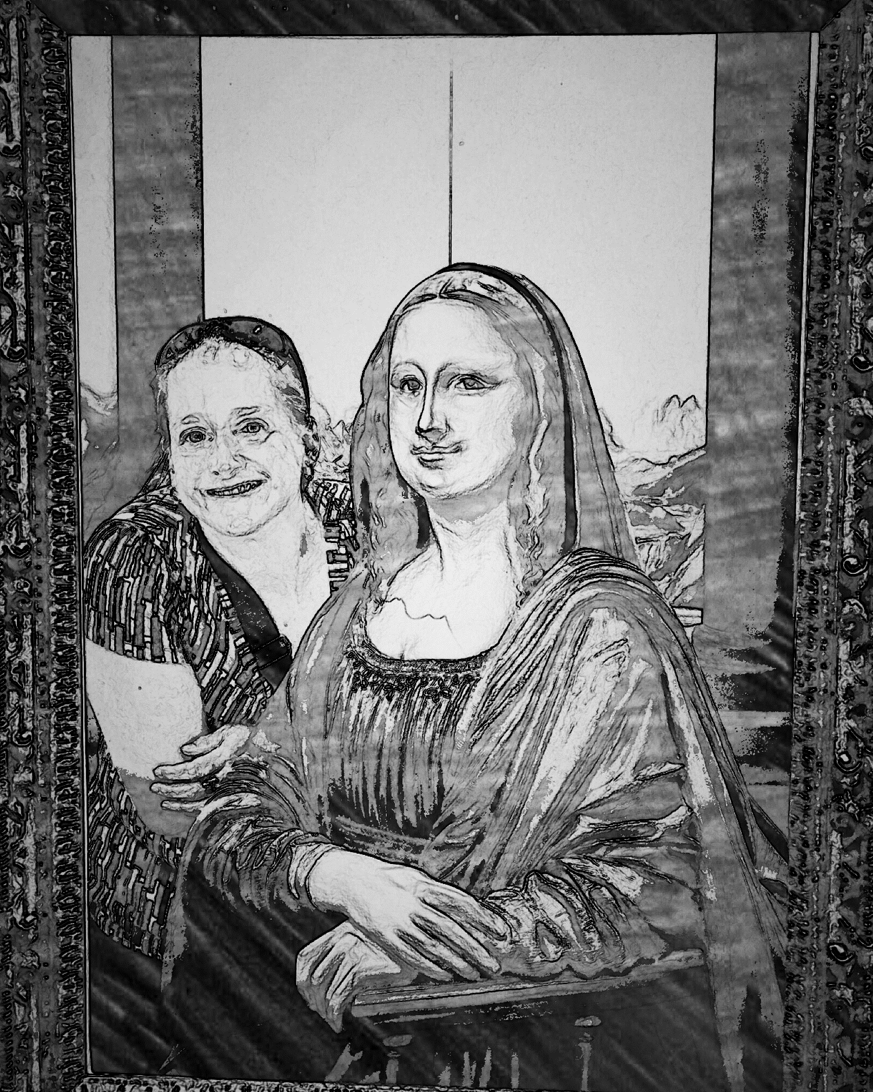
Foundations of Art
Course Overview
Ms. Fox / room J112
jfox@ccps.org /

Course Description: students will be introduced to the elements of art and the principles of design. The elements and principles will be utilized in artworks inspired by different artists and world cultures. Various media will be used for drawing, painting, 2-D design, printmaking, and 3-D sculptures. Foundations class is designed for participants to learn through discovery and creative problem solving.

The course was designed to follow these key concepts.
• Meaningful, hands-on learning experiences that allow for personal growth and creative expression.
• Integration of aesthetics, art criticism, art history, and studio production.
• Sequentially planned experiences that build on concepts and provide learning opportunities that.
incorporate a variety of media, artistic styles and historical periods

Required Materials: Please bring a pencil and eraser to class. A folder with pockets and brads, will
be provided. It is expected the class folder remain in class each day. When
absent, distributed materials will be placed there.

Grading Criteria: There are two types of grades as explained below:
Type of Assessment  Weighted Percentage of Final Grade | Formative Assessments  40 % | Summative Assessments  60%
Minimum per marking period | 6 formative assessments  (3 formatives by interim) | 3 summative assessments
Qualities of Assessment | - Provides teacher with snapshots of student understanding  - Provides teacher with data to help guide future instruction  - Provides students with feedback on next steps and understanding of content  - Short, quick turnaround | - Comprehensive assessments  - Documents mastery of content  - May include multiple concepts and/or skills  - Graded within 10 days of completion
Retake | Yes, within 10 days of return | Yes, within 10 days of return
Examples (may include but are not limited to) | Worksheets, sketches, short written assignments, homework | Tests, quizzes, essays, art projects

The following chart depicts the scales used to calculate end-of-marking period and end-of-course grades. Percentages earned for marking period grades as well as quality points will reflect actual scores and will not be "rounded up."

Percentage | Letter Grade | Quality Point | Final Grade Range
93-100% | A | 4.00 | 3.75-4.00
90-92.9% | A- | 3.67 | 3.48-3.74
87-89.9% | B+ | 3.33 | 3.20-3.47
83-86.9% | B | 3.00 | 2.80-3.19
80-82.9% | B- | 2.67 | 2.50-2.79
77-79.9% | C+ | 2.33 | 2.20-2.49
73-76.9% | C | 2.00 | 1.80-2.19
70-72.9% | C- | 1.67 | 1.50-1.79
67-69.9% | D+ | 1.33 | 1.20-1.49
60-66.9% | D | 1.00 | 0.70-1.19
0-59.9% | F | 0 | 0-0.69
Final Grades will be calculated by averaging quality points earned from each marking period.

Extra credit and homework will not be used to improve students’ grades.

Attendance and Make-up Policy: Students who are absent from class when an assignment is given may make-up the work regardless of reason for absence. A minimum of two class days will be allowed for each day of absence. Assignments such as worksheets, sketchbook drawings, teacher-made quizzes, and artist statements must be turned in within the time allotted. It is the student’s responsibility to be prepared for class and to seek work they need to make up if absent from class. If the assignment is turned in beyond the allotted number of days, it is considered late work.

Late Work Policy: Students may turn in late work regardless of the reason. A minimum of two class days will be allowed for a late assignment with an academic penalty of not greater than five percent per late day of the assignment's total grade. If the assignment is turned in beyond the allotted number of days, such as worksheets, sketchbook drawings, written activities, etc., the assignment will lose a full letter grade for each day late. Large art projects will be issued a due date to stay on track. However, if a student is not able to complete the project by the given due date, the student will have until the end of the current marking period to turn it in. It will be the student’s responsibility to complete that project during spare time out of class, before or after school. The student must make an appointment ahead of time with the teacher.

Level Up Day:
This class will follow the school eight day revisit schedule. Generally students will have a class period approximately every eight days without new instruction for review and extra work time on projects, or enrichment activities.

Assessment Re-take Policy: Students may complete retakes on all assessments (formative and summative) that earn less than a 75%.
- Assessments may be retaken during the school day or at a mutually agreeable time.
- The retake may be same assessment, a comparable assessment, and/or assessment corrections {as outlined by the instructional coordinator.}
- If a student retakes an assessment, the highest grade he/she can earn is an 75%.
- Students will retake the assessment within ten (10) school days after the initial assessment has been graded and returned.

Teacher Contact Information: I may be contacted through email or by phone through the school 410-996-5000 ext. 44912 (The system is new, so please hang on or try again if I lose you.) My planning period is during the 3rd Block on A days and 1st Block B days. Let me know how it is best for me to communicate back with you, such as times, and mode of communication. If a student wishes to come before or after school to complete any work, they just need to discuss it with me. To be sure I will be present. The teacher will not stay after for students unless they are present in class and consistently working during class time, or need extra time. I value my time and that of my students.

Behavior Expectations:
The Definition of Excellence
Arriving to class:
• Promptly being seated.
• Prepared to get on task.
• With a positive attitude.
Class Participation:
• Respect yourself and others right to a quality education.
• Open your mind to ideas and opinions of your own and others.
• Take responsibility for your learning.
Procedures:
• Be mindful of class clean up.
• Be self-disciplined.
• Use time wisely.
The Successful Student:
• Full-fills the criteria of the assignment and goes one step beyond with creativity or a new approach.
• Shows good craftsmanship through careful and neat use of techniques.
• Spends maximum time working in class and more outside of class.
• Is open to suggestions from the teacher and other students.
• Works at or near their highest level with a positive attitude.
• Cleans up and leaves things better than they were found.
• Takes care of art supplies, facilities, and equipment.
• Follows directions carefully
DISIPLANARY ACTION
All policies governing Elkton High School, found in the Student and Parent Handbook, are applied in this classroom. Take the time to read it so that you fully understand your rights and responsibilities. We will go over safety points at the start of class.
Please note the county policy on electronic devices, such as iPods, cell phones, and electronic devices are allowable at specified times for specific purposes. Please ask first, just to be sure, if it is allowed and an appropriate time.
ACADEMIC DISHONESTY
Academic dishonesty includes all of the following: copying someone else's work, allowing someone else to copy his/her work, allowing someone to complete his/her work, completing someone else's work, and using technology resources inappropriately or handing in anyone else’s work as your own. If a student is caught cheating or plagiarizing he/or she will be referred for disciplinary action and given a 0% until they replace that grade with a comparable assignment.
DRESS CODE Policy
School/Professional clothing Non-professional/School Inappropriate Clothing

Tardy Policy – must be in the door by the bell

1st
2nd
3rd
4th
5th

School Wide Cell Phone Policy

Emergency Procedures:
Fire Drill- Code Yellow- ALICE-

