Baranski, Madeline
Pictures and Crap
Previous Photo
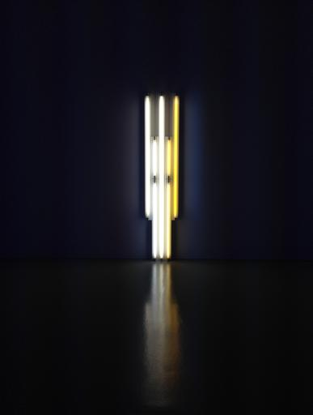
I took this photo last year at the Hirshorn Museum in D.C. I took it because I wanted to capture the way the light was reflecting off of the floor, also there was a sign that said, "no photography", and I'm a teenager so how was I supposed to resist? This photo was taken on an iPhone 5c.
Grab Bag
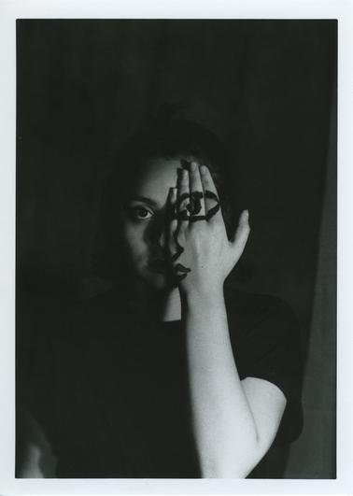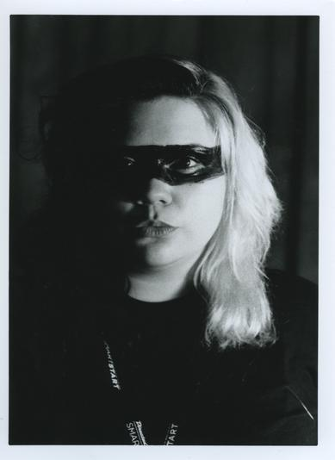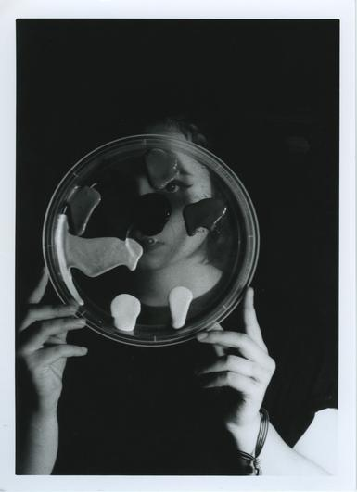
This was my best series because of how the contrasty lighting created such a dramatic effect. I am proud of these photos because of how beautifully they printed on the first try.
Pictorialism
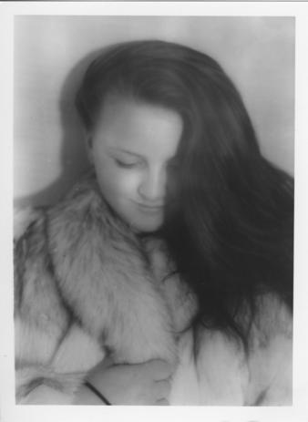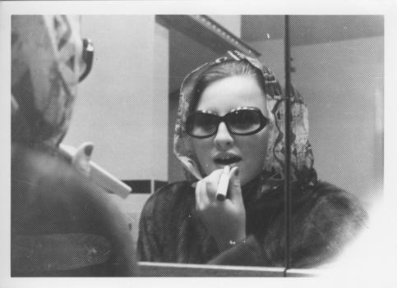
I dressed Kassidy up in my grandmother's vintage clothes and furs because I wanted to shoot this assignment with a vintage theme. I tried out a lot of different filters and decided on these specific filters because they were the vintage style I was going for. That's also the reason I wanted the dust and scratches on the negatives. I'm really happy with the way they turned out and had a lot of fun shooting this assignment. I wanted it to look like something you would find in your grandmother's attic.
Juxtapositions and Reflections
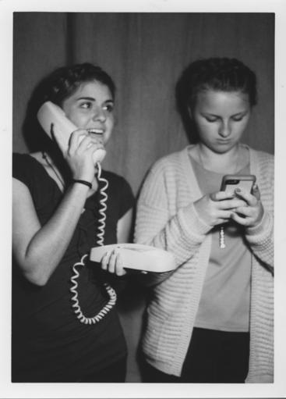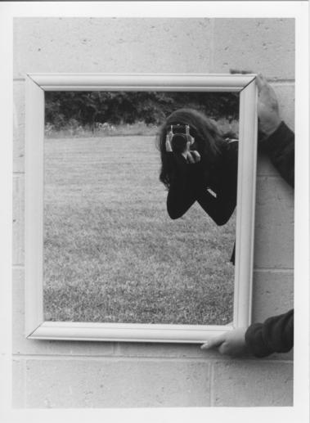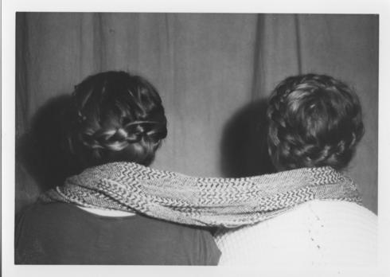
I had fun shooting this assignment because it was a challenge to photograph juxtapositions in school. All of the juxtapositions on the internet look really planned out and extravagant, but the ones I shot in school turned out really well. I like how original they are.
Digital Coloring
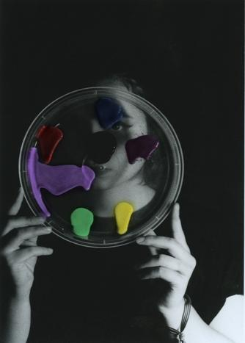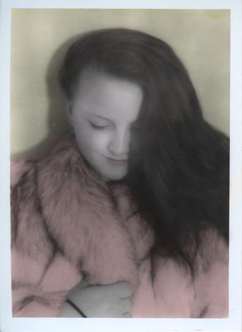
This was fun because I got to express my creativity by adding color to black and white pictures. It was fun adding a little flare.. even though I had to restart the one of Genesis a couple of times. But, it turned out how I wanted.
Painting with Light
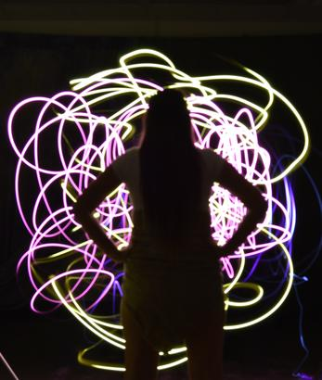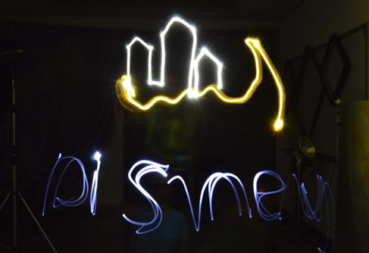
This was a challenging project because it took awhile to get the finished project, but it's Disney themed so that made it okay. The first one is supposed to be kind of Pocahontas themed and the second one is supposed to resemble the logo thing at the beginning of the movies.
This is My Life
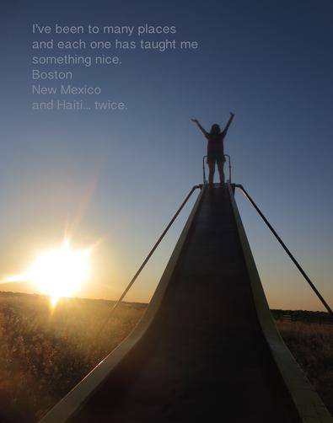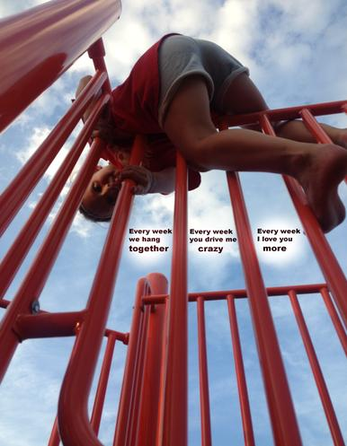
I hated this project with every fiber of my being; with all of my heart, mind, and soul. I hope future students will be free of this horrid assignment. I am not a poet and I had no desire to share personal aspects of my life with the whole class. But I guess the final products didn't turn out too horribly... mostly because I was trying not to take myself too seriously while thinking of what to write.
Panoramic
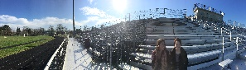
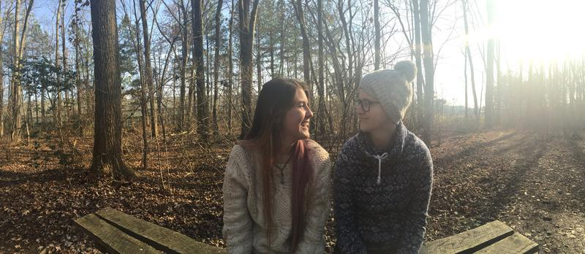
I like these two the best because while I told them to sit, the laughter is completely candid and I think it captures the essence of our friendship. Also, I liked that we were able to shoot outside.
Burst
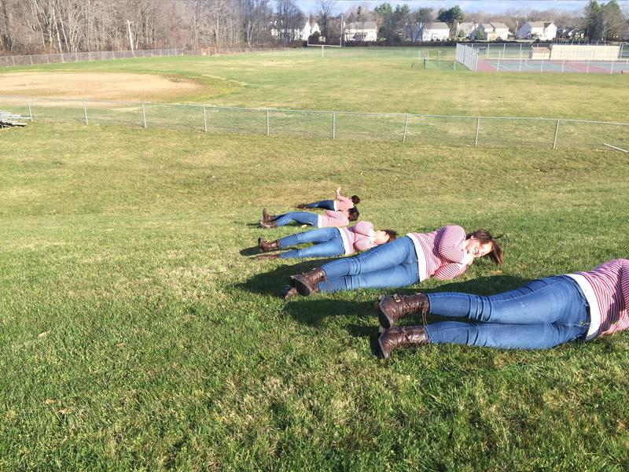
This project was challenging because my background shifted and all the subjects are touching at least a little bit. I had to sacrifice some shadows in order to fit all the Kassidys in the picture. I'm pretty happy with how it turned out, but if I were to do it again I would take a burst that would space my subjects out more.
Artist Statement
1. My favorite photographic tool is the film camera. I like how simple it is and the fact that you only have one chance to get the shot right, so it requires you to be more careful and put more thought into what you're about to shoot. Another reason I like it so much is because I really enjoy the whole film process.
2. My favorite photographic material is film paper. I'm not sure what kind we use, but I really like the size and the border around the edge. It makes it seem more professional and important. Also, I like that it's not too glossy.
3. What I like best about taking pictures is that I get to freeze one moment in time forever; it's like I personally helped save a piece of history. I also really like photographing humans instead of inanimate objects because I love the amount of emotion they are able to express.
4. When I say a piece turned out really well, I mean that, even if it didn't turn out how I had hoped, it looks aesthetically pleasing and/or it would make a person think or feel something when they look at it.
5. Some patterns in my work are that I like things to be a bit underexposed and dark. Also, I like photographing people, mainly their face.

